High Demand UBER AreasReport

short line

Sepideh Berangi (S3793021)

Mohammad Farshidmehr (S3308107)  
24th May 2020

### Contribution Agreement

# **High Demand UBER Areas**

**ParsGroup**

|  |  |
| --- | --- |
| Student Name: Sepideh Berangi | Student Name: Mohammad Farshidmehr |
| Student ID: S3793021 | Student ID: S3308107 |
| Contributions:  Sepideh Berangi 50% | Contributions:  Mohammad Farshidmehr 50% |
| Contribution Percentage: 50% | Contribution Percentage: 50% |
| *By signing below, I certify all information is true and correct to the best of my knowledge.*    Signature: Sepideh Berangi    Date: 17 May 2020 | *By signing below, I certify all information is true and correct to the best of my knowledge.*    Signature: Mohammad Farshidmehr    Date: 17 May 2020 |

### Link

Our application is working over an android application. The data analyses that will be generated by AWS will appear in PHP site as a chart and mpas in below links:

http://

### Summary

With our mobile app, the clients will be able to access their current location information or any specific part of the map, and it will display the demand rate of user requests based on the data provided by UBER. This information could be useful for UBER to identify the location of busy areas, for profiting more in their business. In addition, this data will be useful for the local government's traffic governance and the police to check the traffic flow of certain areas in order to improve their services.

### Introduction

It’s vital for every sort of business to identify the highly requested areas in order to perform better and be able to plan for their future. Businesses, Police, and Government would want to know where are the most visited and crowded locations in the city to be able to enhance their services.

In this application, we have aimed to identify the busy and high demand areas based on the data provided by UBER. Firstly, it could help companies and people who are keen to open a new business such as restaurants, insurance companies, banks, etc. Secondly, it could give some important information to the local police. From the location and crowd flow, they can provide the necessary equipment and security force to insure the security of the area. Finally, the local government can leverage this information to improve the current infrastructure of the city to do construction in targeted and demanding locations.

This application requires information that is published by the UBER company which is the greatest limitation of our process due to the fact that UBER will release its own customer data every three to five years. The suggestion to resolve this issue is to sign a contract with UBER under their own policies that these data will only be used in this application. This solution requires loads of expenses. However, the application works fine at the moment (working with the data already provided by UBER) and could be installed by a lot of people who may have a good offer from UBER or another company as well.

The information provided in our app, could be very useful in real life because the analysed information of the locations would be vital for the police, government, people, and businesses. People would be motivated to use this application by enough advertisement, to access better and more accurate analysis of the data.

1. What are the motivations behind your idea? WHEN REVIEW WILL FINISH PLEASE DELETE LINES
2. What does it do?
3. Why is it required?
4. How can it be used as a real-life application?
5. The advantages/positive/new things of your application.

### 

### Related work

**The Traveltime website [1]** is one of the websites that give information to the user base of three factors PostCode, Map and travel time. The results that analyse and show to the users are talking about time duration from employee to arrive at their workplace. It gives good information but is not useful for people who want to open or improve their business.

### Software design/architecture

This application is working in two parts Android mobile application and AWS service.

* Android mobile application side

The services that are using in the mobile application side are

* Cloud tools for Android
* Cloud mobile app
* Cloud API
* Firebase Authentication
* Firebase Cloud storage
* Firebase Cloud Message and notification
* Google Maps API
* Google Maps GPS
* App Analytics
* Data Analytic Services

Services used to generate the clusters are:

* JAVA
* AWS-EMR
* EC2
* IAM
* AWS-S3 Bucket

Services used for analysing the output data are:

* BigQuery
* SQL
* R
* GeoViz
* Data studio

## 

Points database structure. The database name is locations and in locations has 6 documents. Each document has a record with 3 string fields. (Lang,Lat) for keeping the location and count to keep the number of samples..

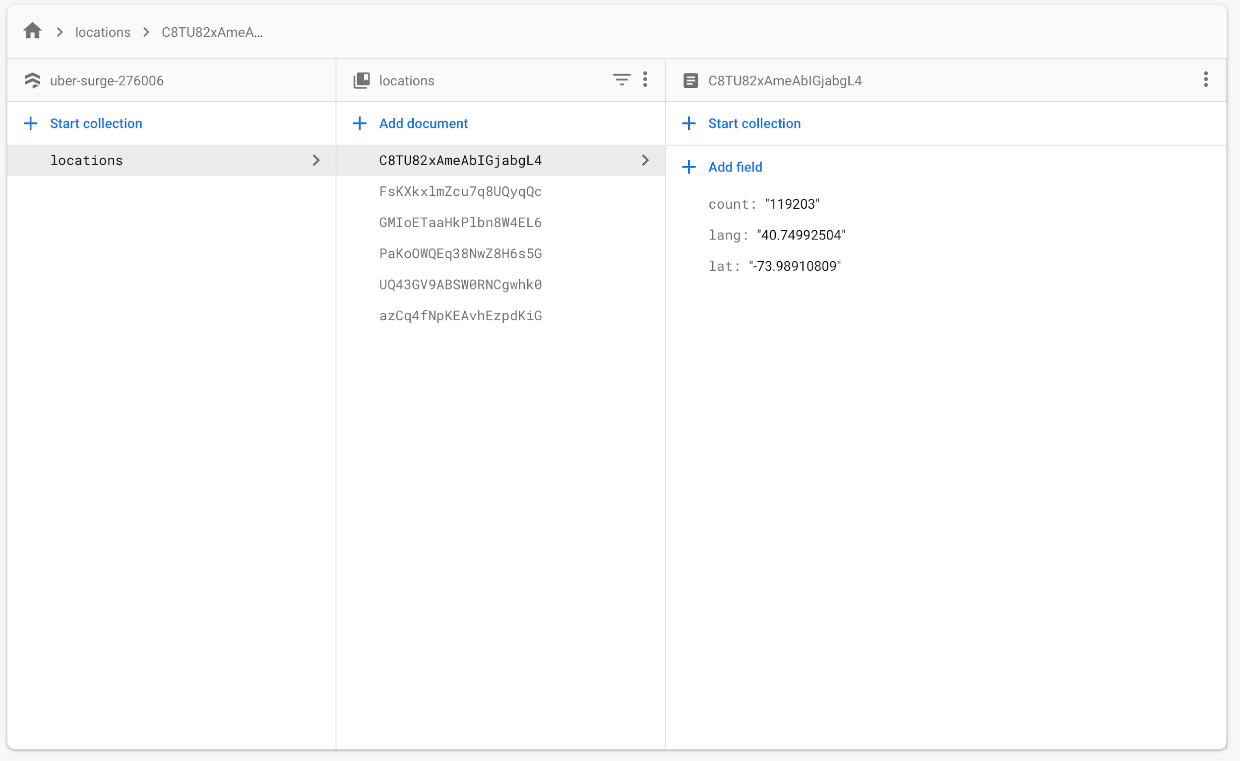

Authentication database which is the default Firebase data structure that each record contain Identifier,Providers,Created, Signed In and User UID for keeping user information

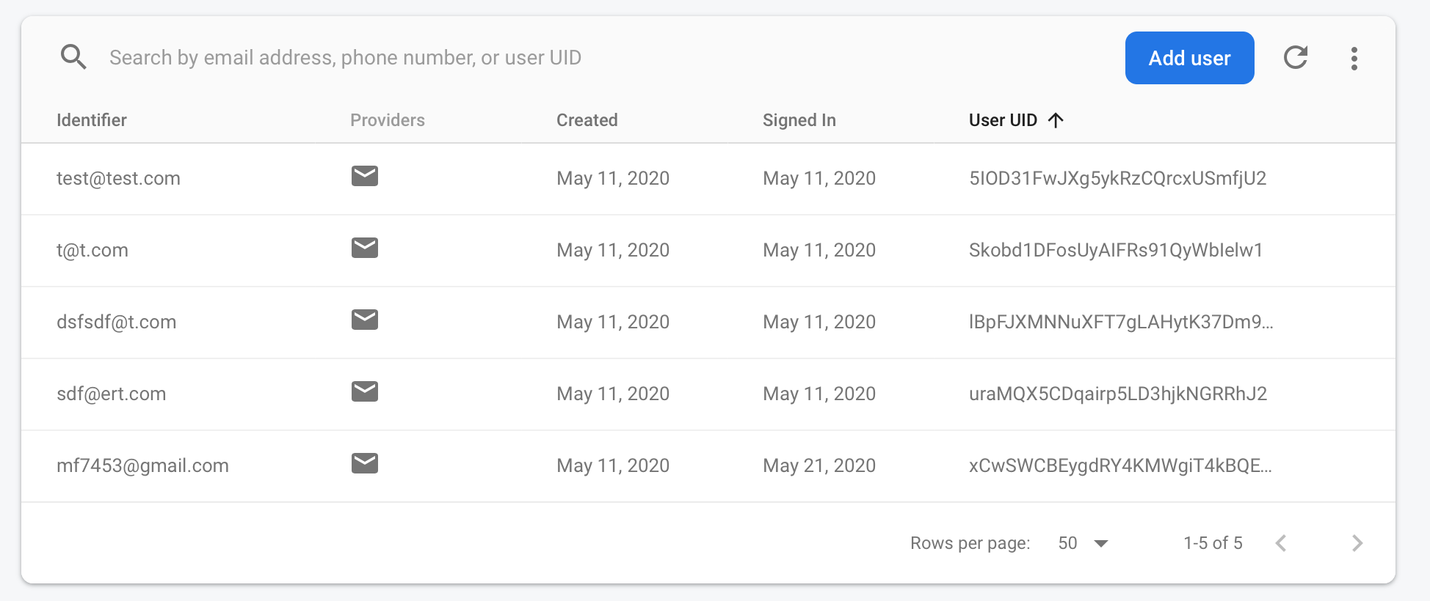

i. A high-level architectural diagram that shows the communication between different cloud components used in your project and the purpose of using those components.

ii. Description of your dataset/data structure/APIs/sensors you used for your project (if any) [use figure if required]

* AWS services

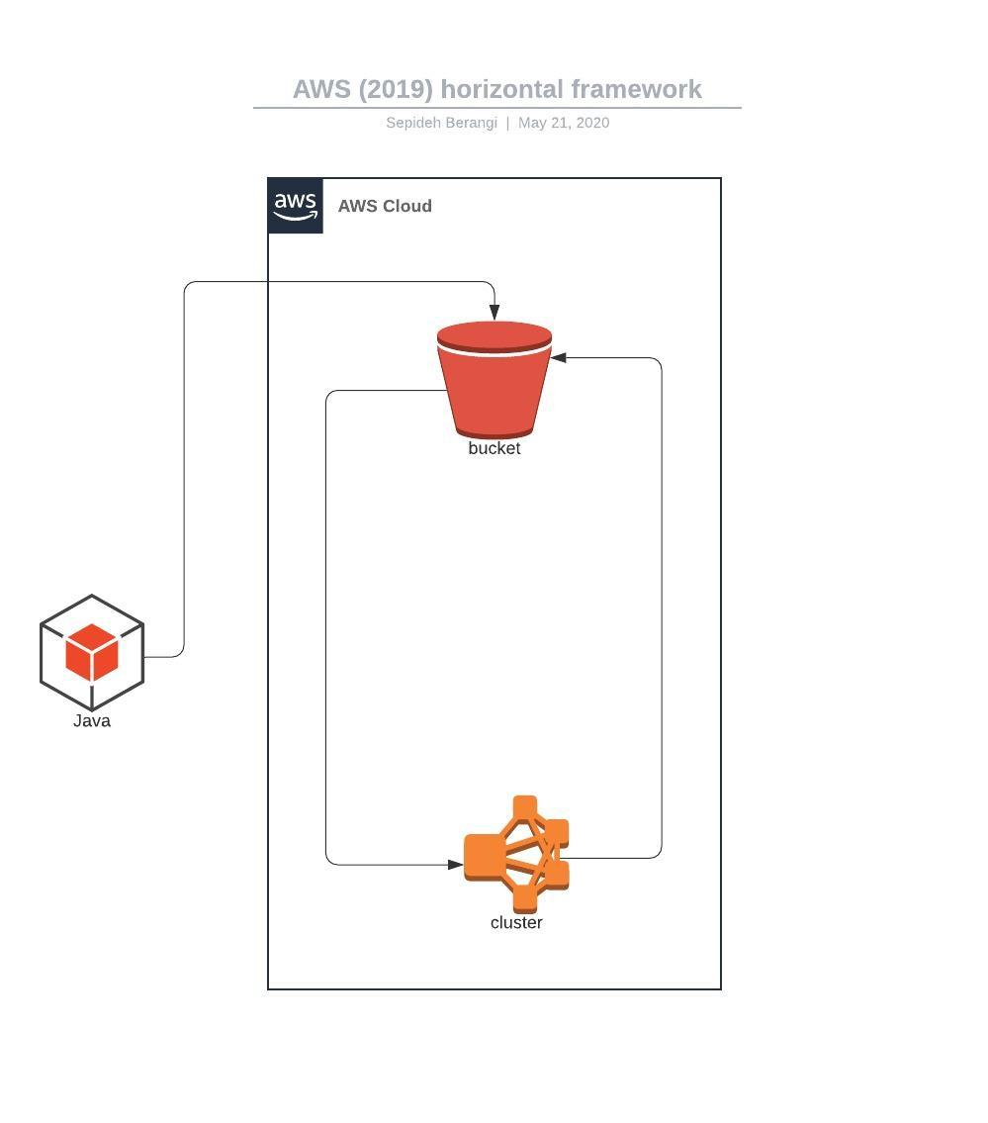

### Implementation

Developer Manual: A step-by-step guideline to reproduce your project [use figure if required] and make it live. This is like our tutorial sheet. For known/general description (e.g. creating a MySQL RDS instance in AWS, deploying the project in Elastic Beanstalk, deploying the project in Google cloud) you can refer to any web link directly. You can also refer to the tutorial sheet if you have similar steps in your description (e.g. deploy the application in Google cloud).

**Note: Google account**

This implementation is a working base of users who should have google cloud accounts. If anyone does not have any google cloud account you can create to follow steps here. <https://cloud.google.com/> and select Get started for free.

1. Login to google account to see the Google Cloud Platform dashboard.

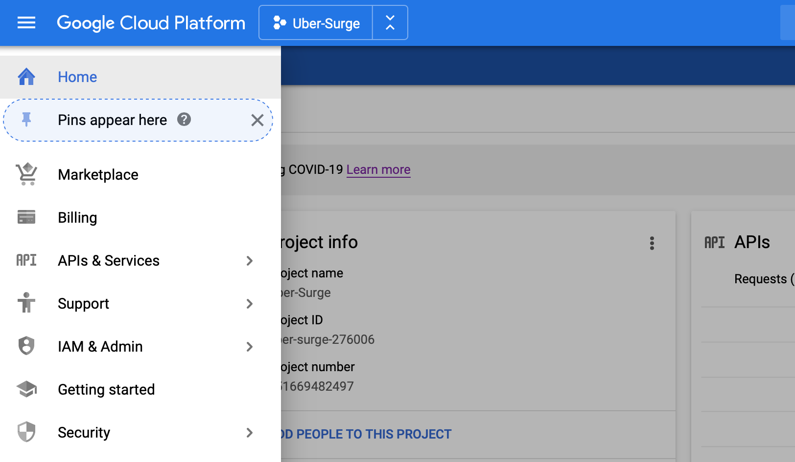

* 1. If there is any project select it and If any projects do not exists create a new one by clicking on the project name. The windows like this will appear and you can follow the link to create a new project.

<https://cloud.google.com/appengine/docs/standard/nodejs/building-app/creating-project>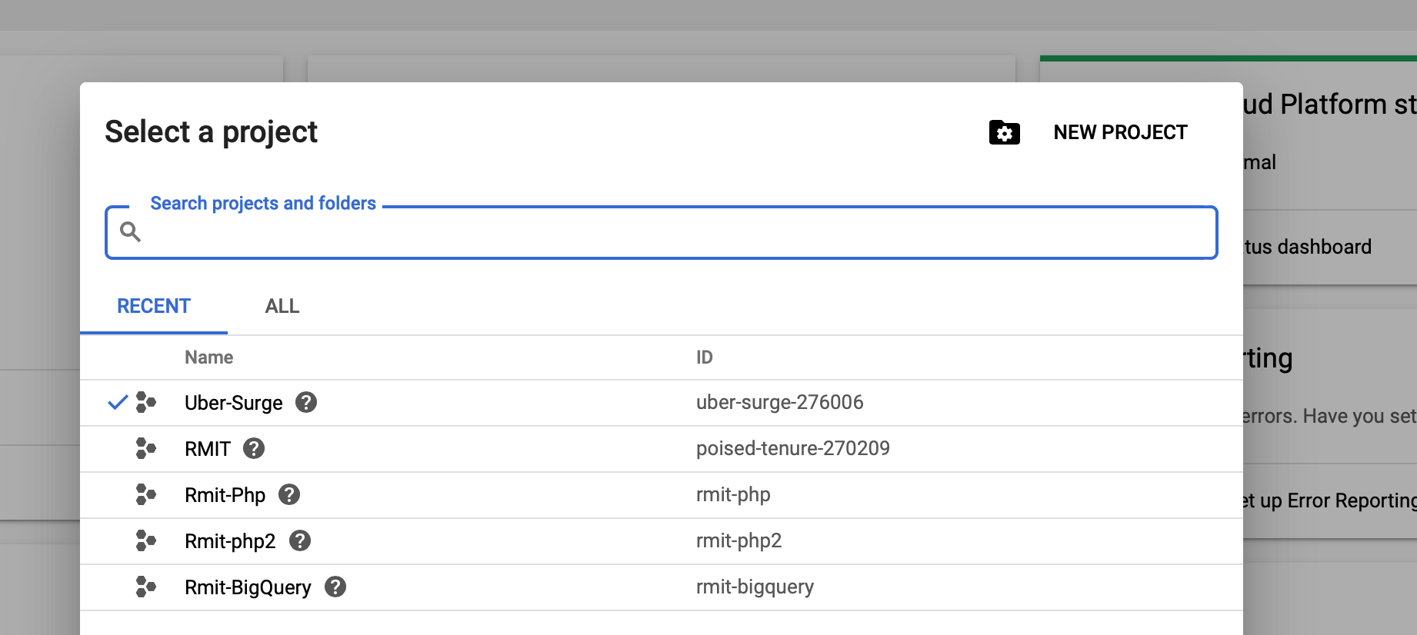

1. Create a Mobile Application
   1. Create a Firebase project

Go to the <https://firebase.google.com> and then select Get Started or select Go to console. If any projects exist there you can select one. If any projects not here you can create it by following 4 easy steps that demonstrate here.

* + 1. Press add project

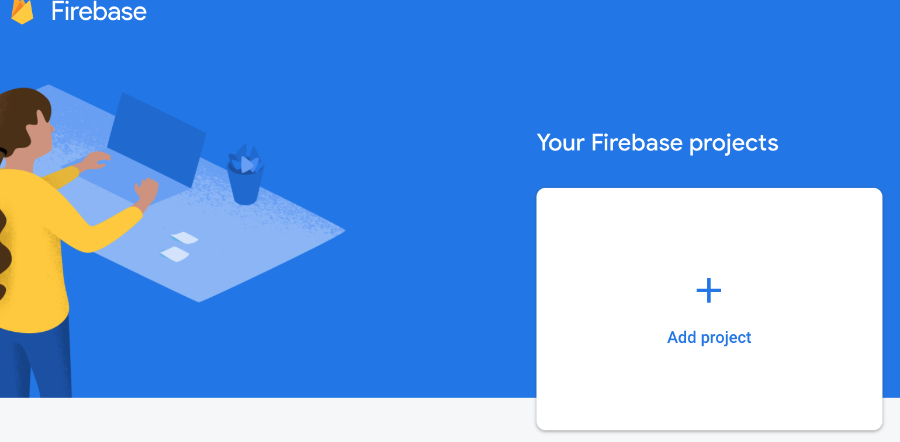

* + 1. Select a name

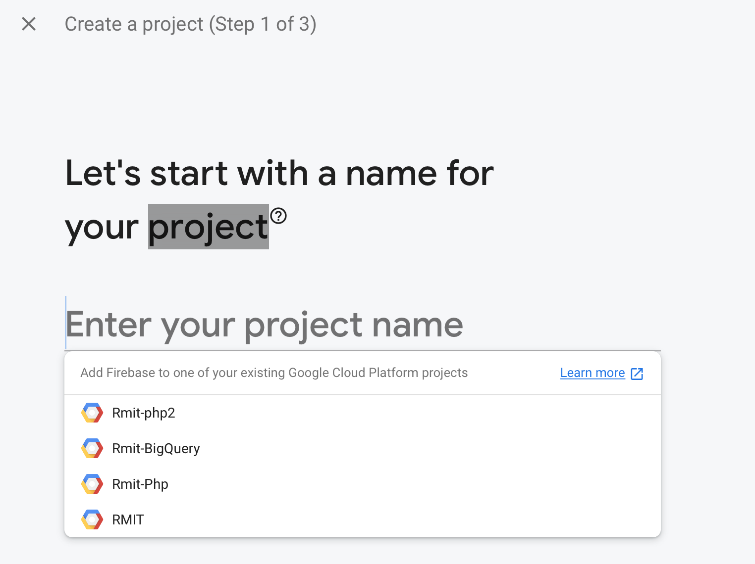

* + 1. Select Continue

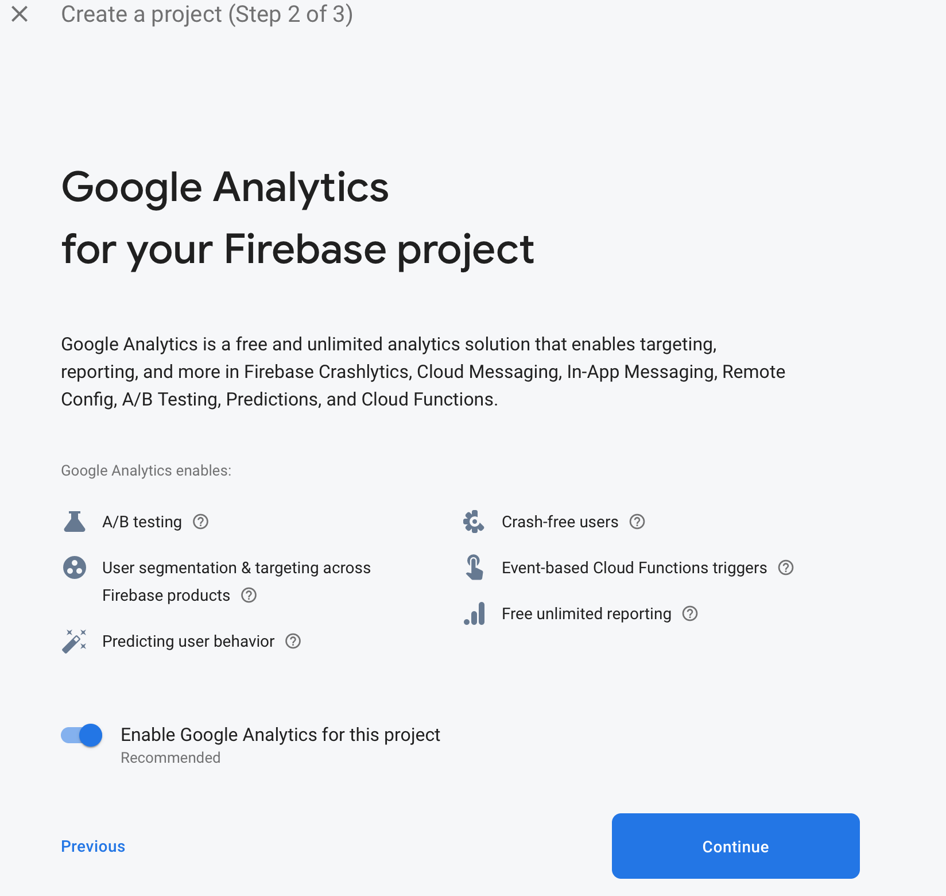

* + 1. Select Analytic account and then press Create Project

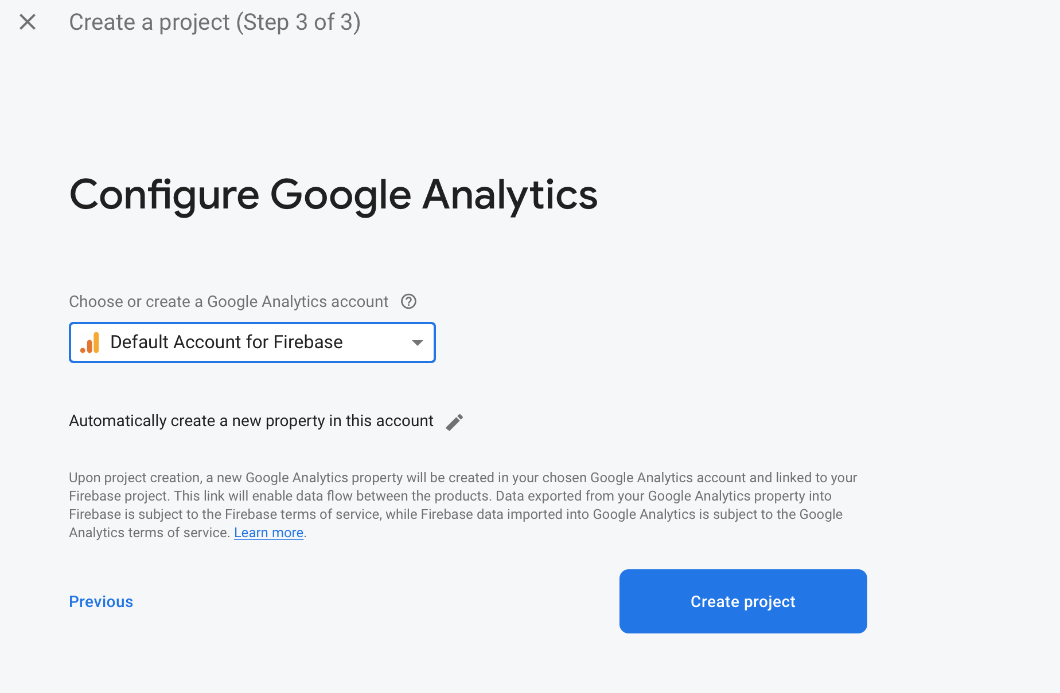

* 1. Add app into Firebase project

If there is any app here you can select it or otherwise you can follow the steps to create a new app.

* + 1. Select Add app



* + 1. Select your platform such as android,ios



* + 1. Give a name and follow wizards to create an app. For more information can follow this link.

<https://cloud.google.com/solutions/mobile/mobile-firebase-app-engine-flexible>

**Make sure to download the config file and save it in the right place.**

1. Install and config Android studio

For creating an android mobile application by following the link. <https://developer.android.com/studio/>

1. Create an Android Application

Follow the below links steps to create a new application in Android Studio

<https://developer.android.com/training/basics/firstapp/creating-project>

**Copy the configuration file to the app folder in Android Studio**

1. Adding Firebase Authentication UI

Firebase Authentication UI is prepared as an authentication feature for each app that can log in to the apps. It gives an option to the user that can create SSO to each mobile application such as (Login by phone number, Gmail, Email, Facebook, Tweeter, Github and Linkedin). This link can explain how to create user authentication for mobile apps.

<https://firebase.google.com/docs?authuser=0>

1. Cloud Storage

For saving data to the database and reading and writing to the database in the mobile application we can use Cloud Storage in firebase for apps. For creating a database and accessing it from a mobile app follow these links.

<https://firebase.google.com/docs/stora>

<https://firebase.google.com/docs/firestore/query-data/get-data>

<https://firebase.google.com/docs/storage/android/start>

1. Cloud Messaging

When a mobile app or application will develop it is necessary to inform users some important information and make them update about everything. For example, the version of an application that will deploy or any other information such as new material or any information that will be prepared and generated by an application that is very important for their users. For adding these features to your application please follow the below links.

<https://firebase.google.com/docs/cloud-messaging/android/first-message>

1. Maps

The best feature for each mobile application is a map. Google developed a strong map API features for clients. Maps can show the current location of mobile devices. It can give useful information for the user such as an address, hotels, restaurants, directions from current location to a specific destination, define home and workplace and so on. Before using Google maps you have to enable Google Map API by following the link <https://support.google.com/googleapi/answer/6158841?hl=en>

After enabling the Google Map API you can use the maps and its features in the mobile application. For using the maps please follow the below links.

<https://console.cloud.google.com/google/maps-apis/overview?project=uber-surge-276006&folder=&organizationId=>

<https://developers.google.com/maps/documentation/android-sdk/start?hl=en_US>

<https://developers.google.com/maps/documentation/android-sdk/map?hl=en_US>

<https://developers.google.com/maps/documentation/android-sdk/location?hl=en_US>

1. Google Analytics

Google Analytics is a web analytics service offered by Google that tracks and reports website traffic, currently as a platform inside the Google Marketing Platform brand. Google launched the service in November 2005 after acquiring Urchin. For add and configure the Analytics feature please follow the steps <https://support.google.com/analytics/answer/1008015?hl=en>

### User Manual

1. Install application from Google play store or run the application from Android studio

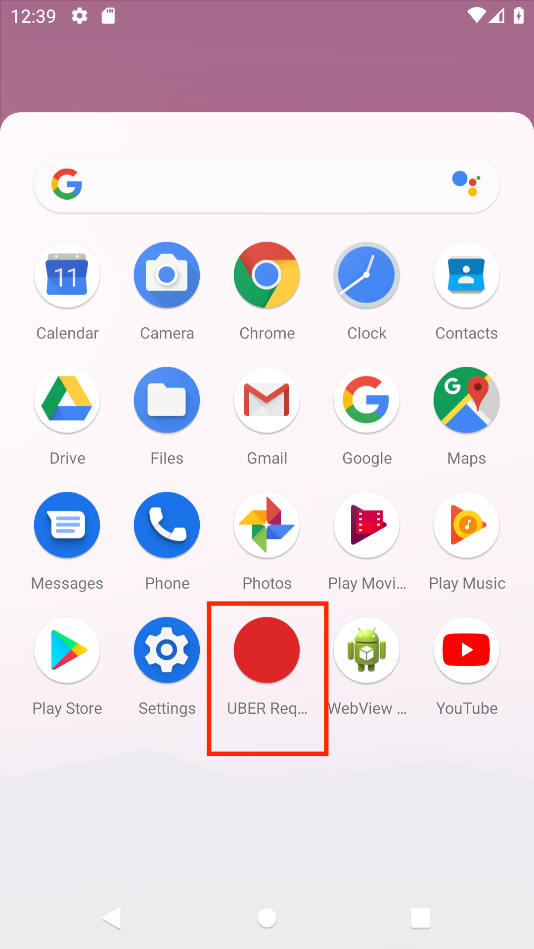

1. Login to application in any way you prefer bu, in this example the email way was selected with password 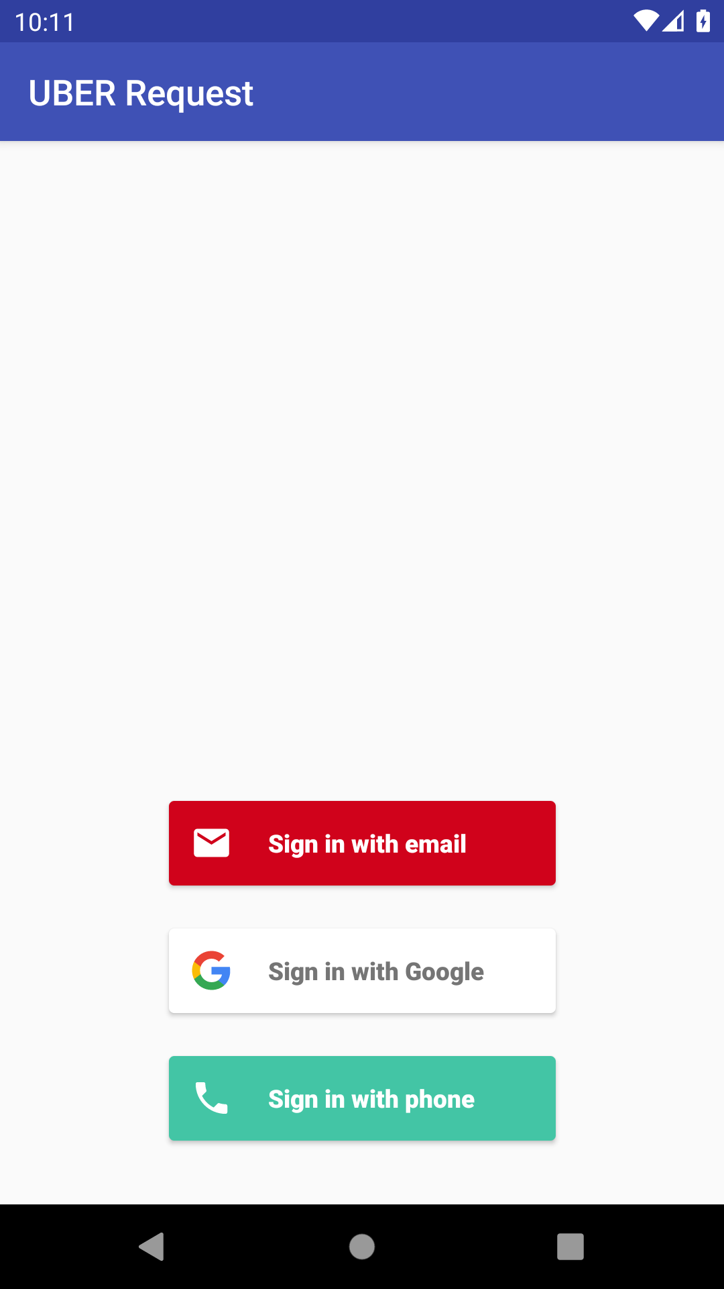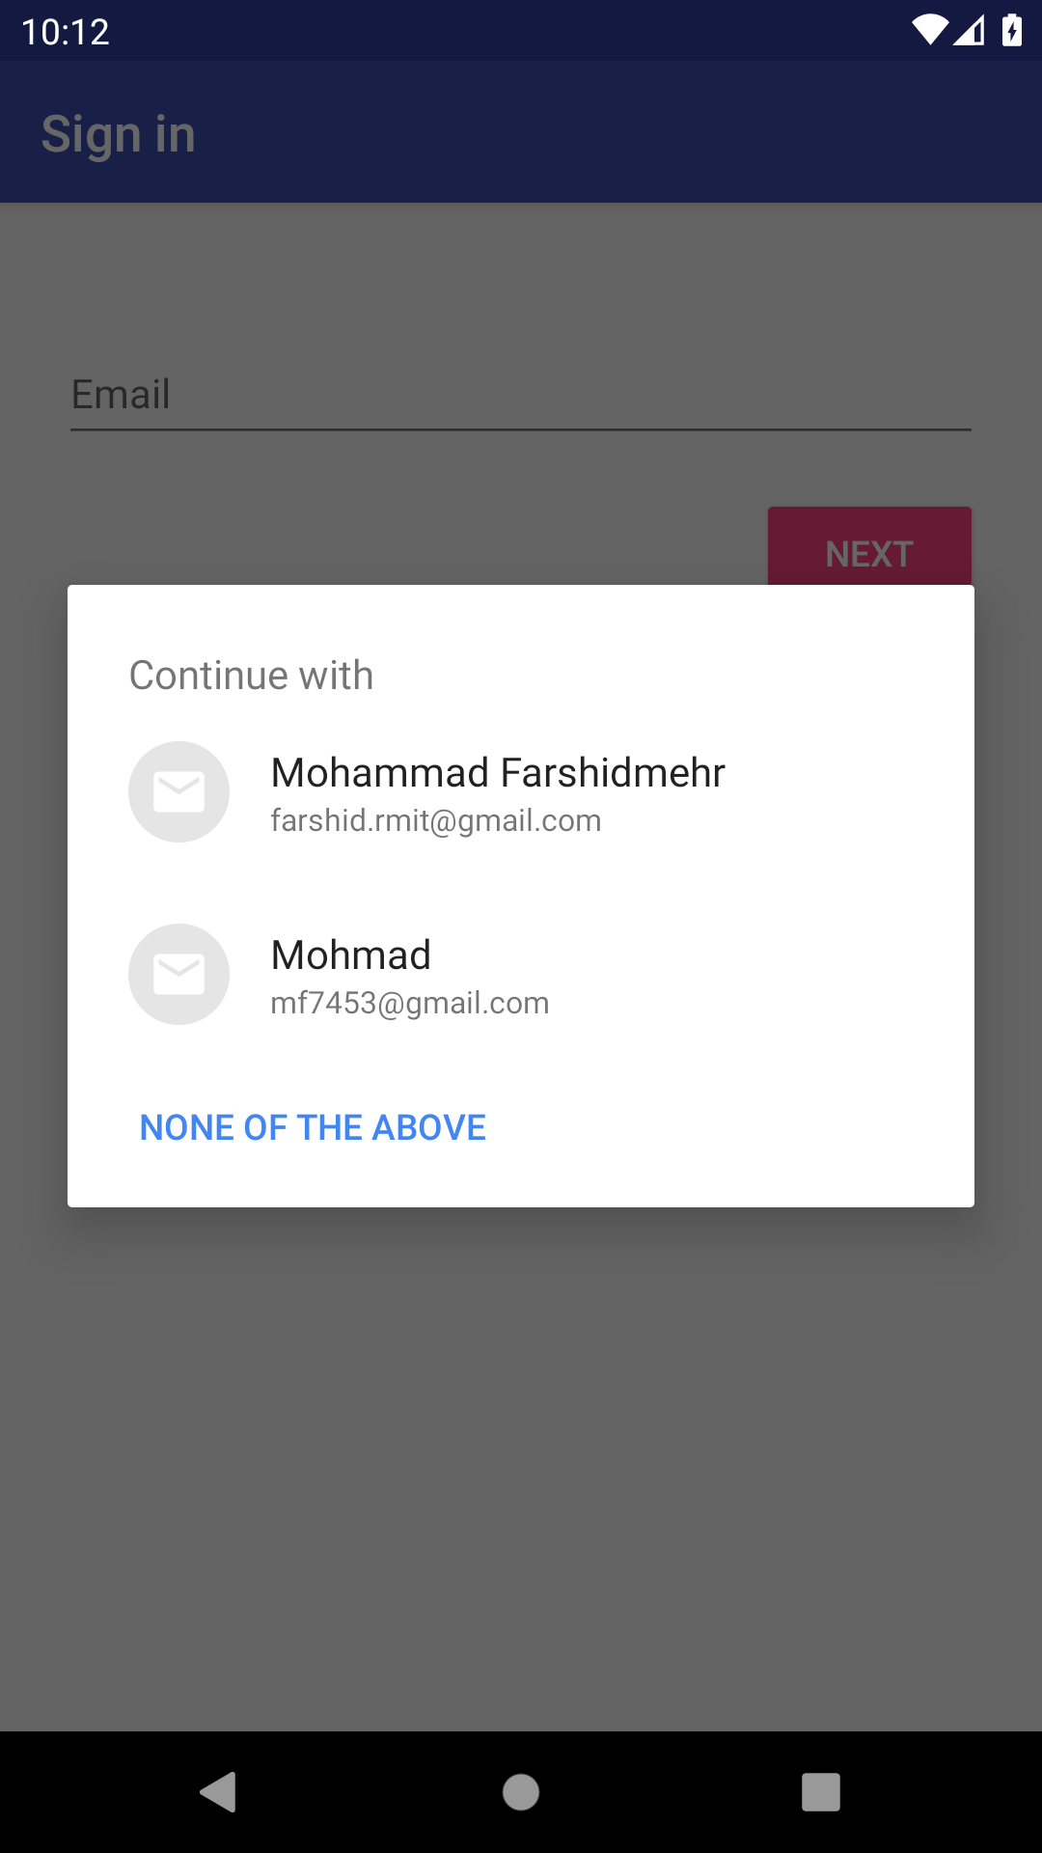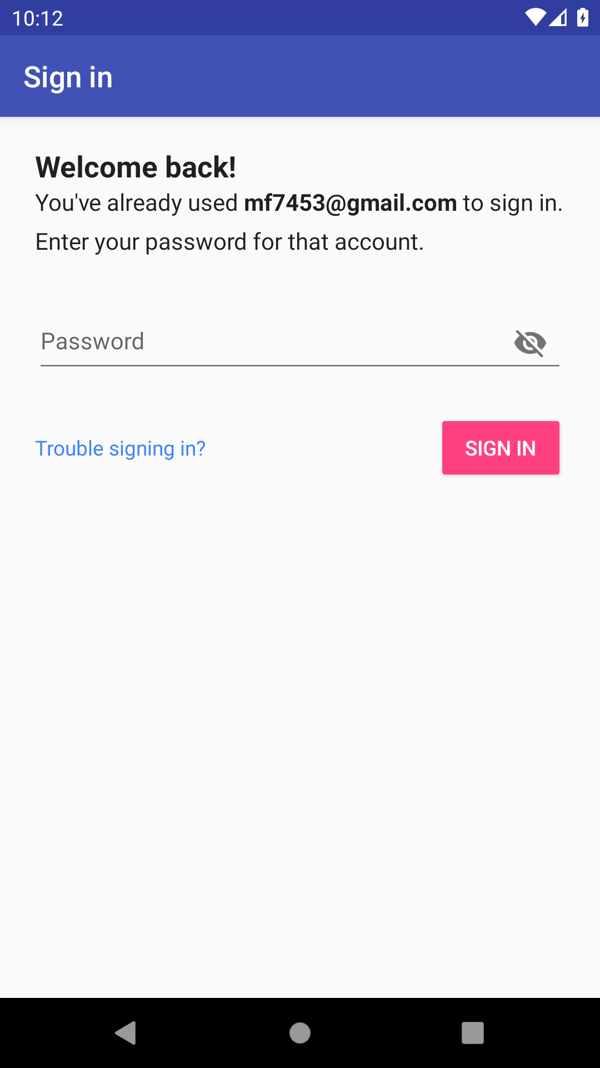
2. Main menu has 5 options. Sign out button to sign out from application and will see the main login page..



1. Second button in Show analyse web that shows the result of the AWS in php web page.

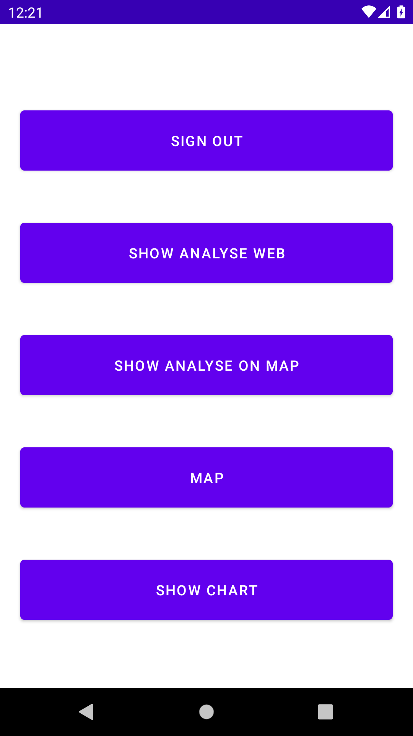

1. Shows an analysis on the map that shows the points from the database and then shows the result in the map that draws a circle around the points which are base points of clustering calculation.

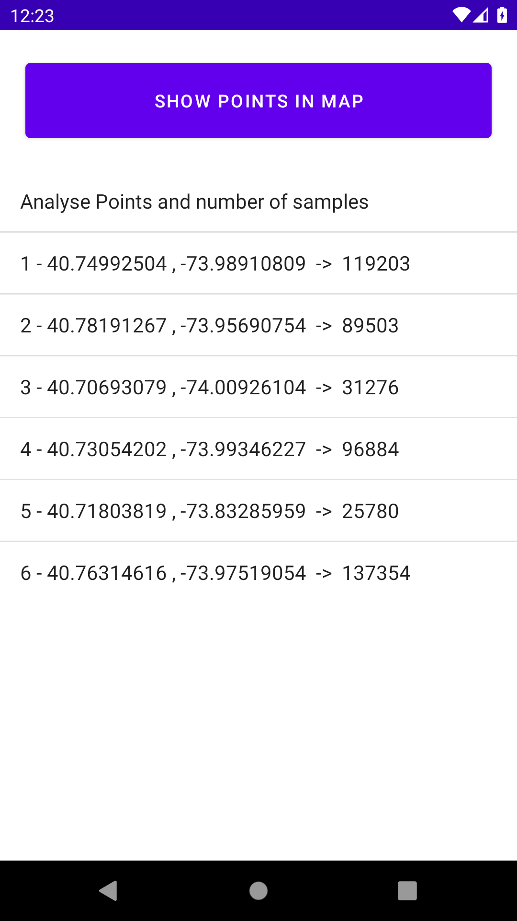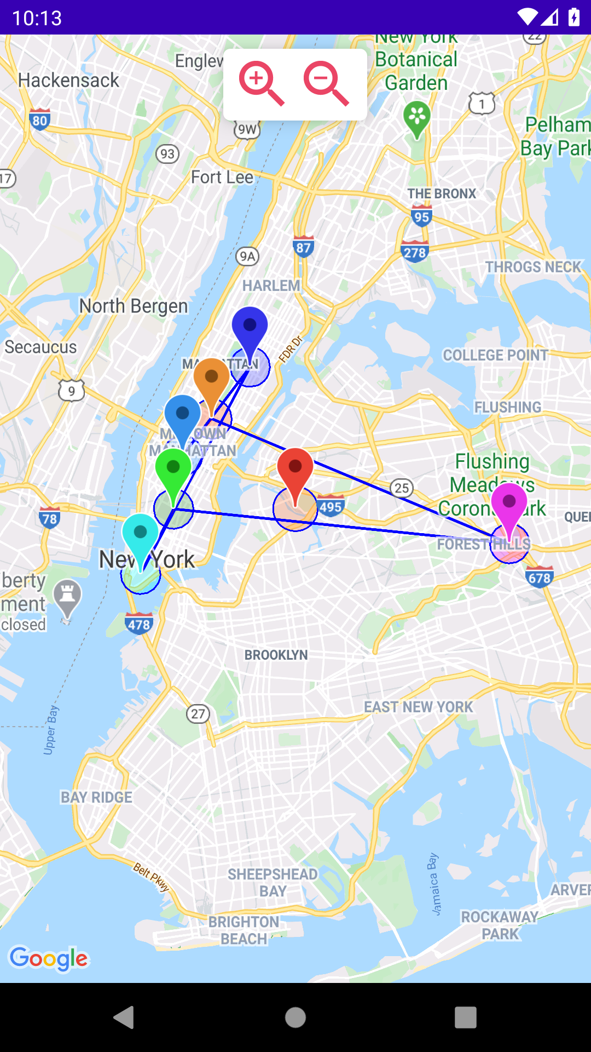

1. The map that has the searching, zooming and current location features.

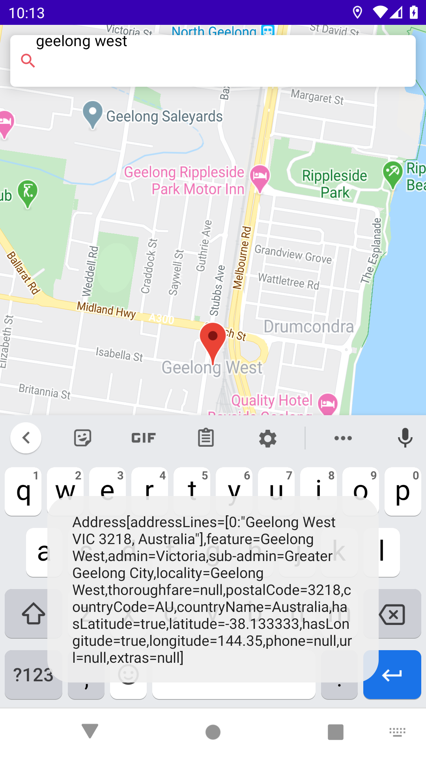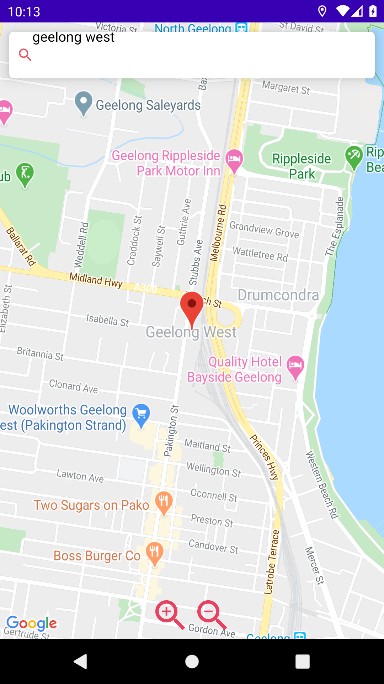

1. The charts that show two types of graph with points and the number of samples for each point

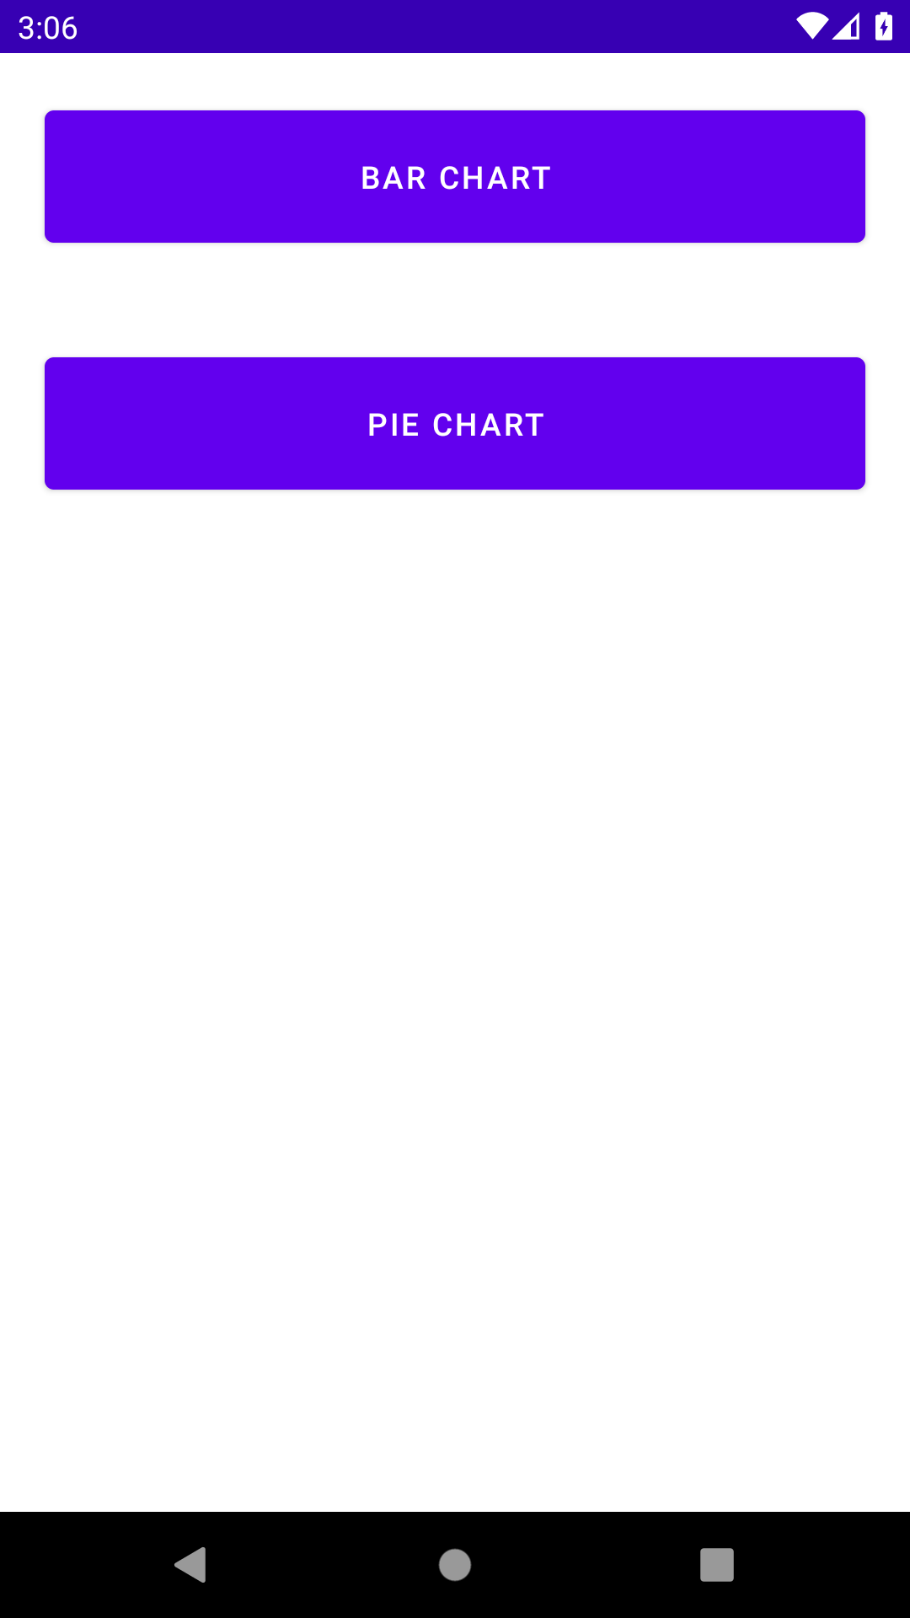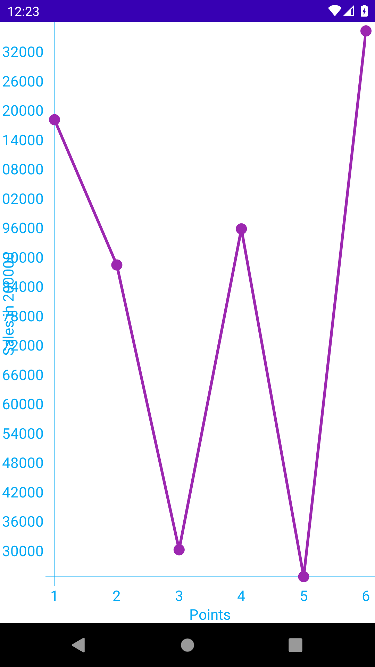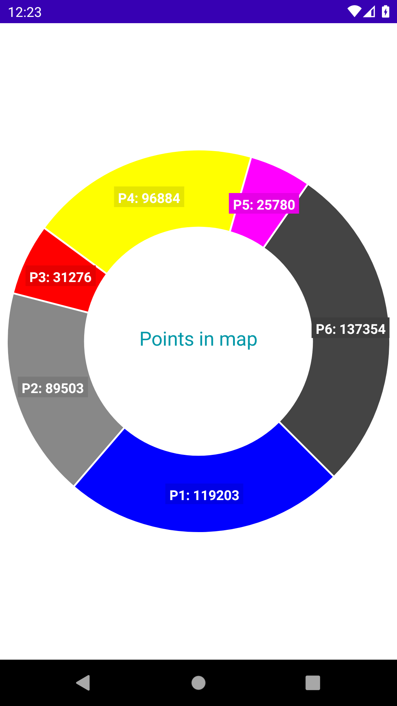

1. The notification that Cloud will send to the apps and user knows should check the app to see the results in the php website.

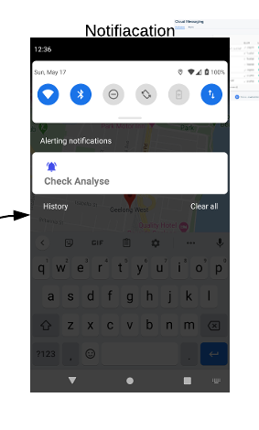

1. Application analytic result..

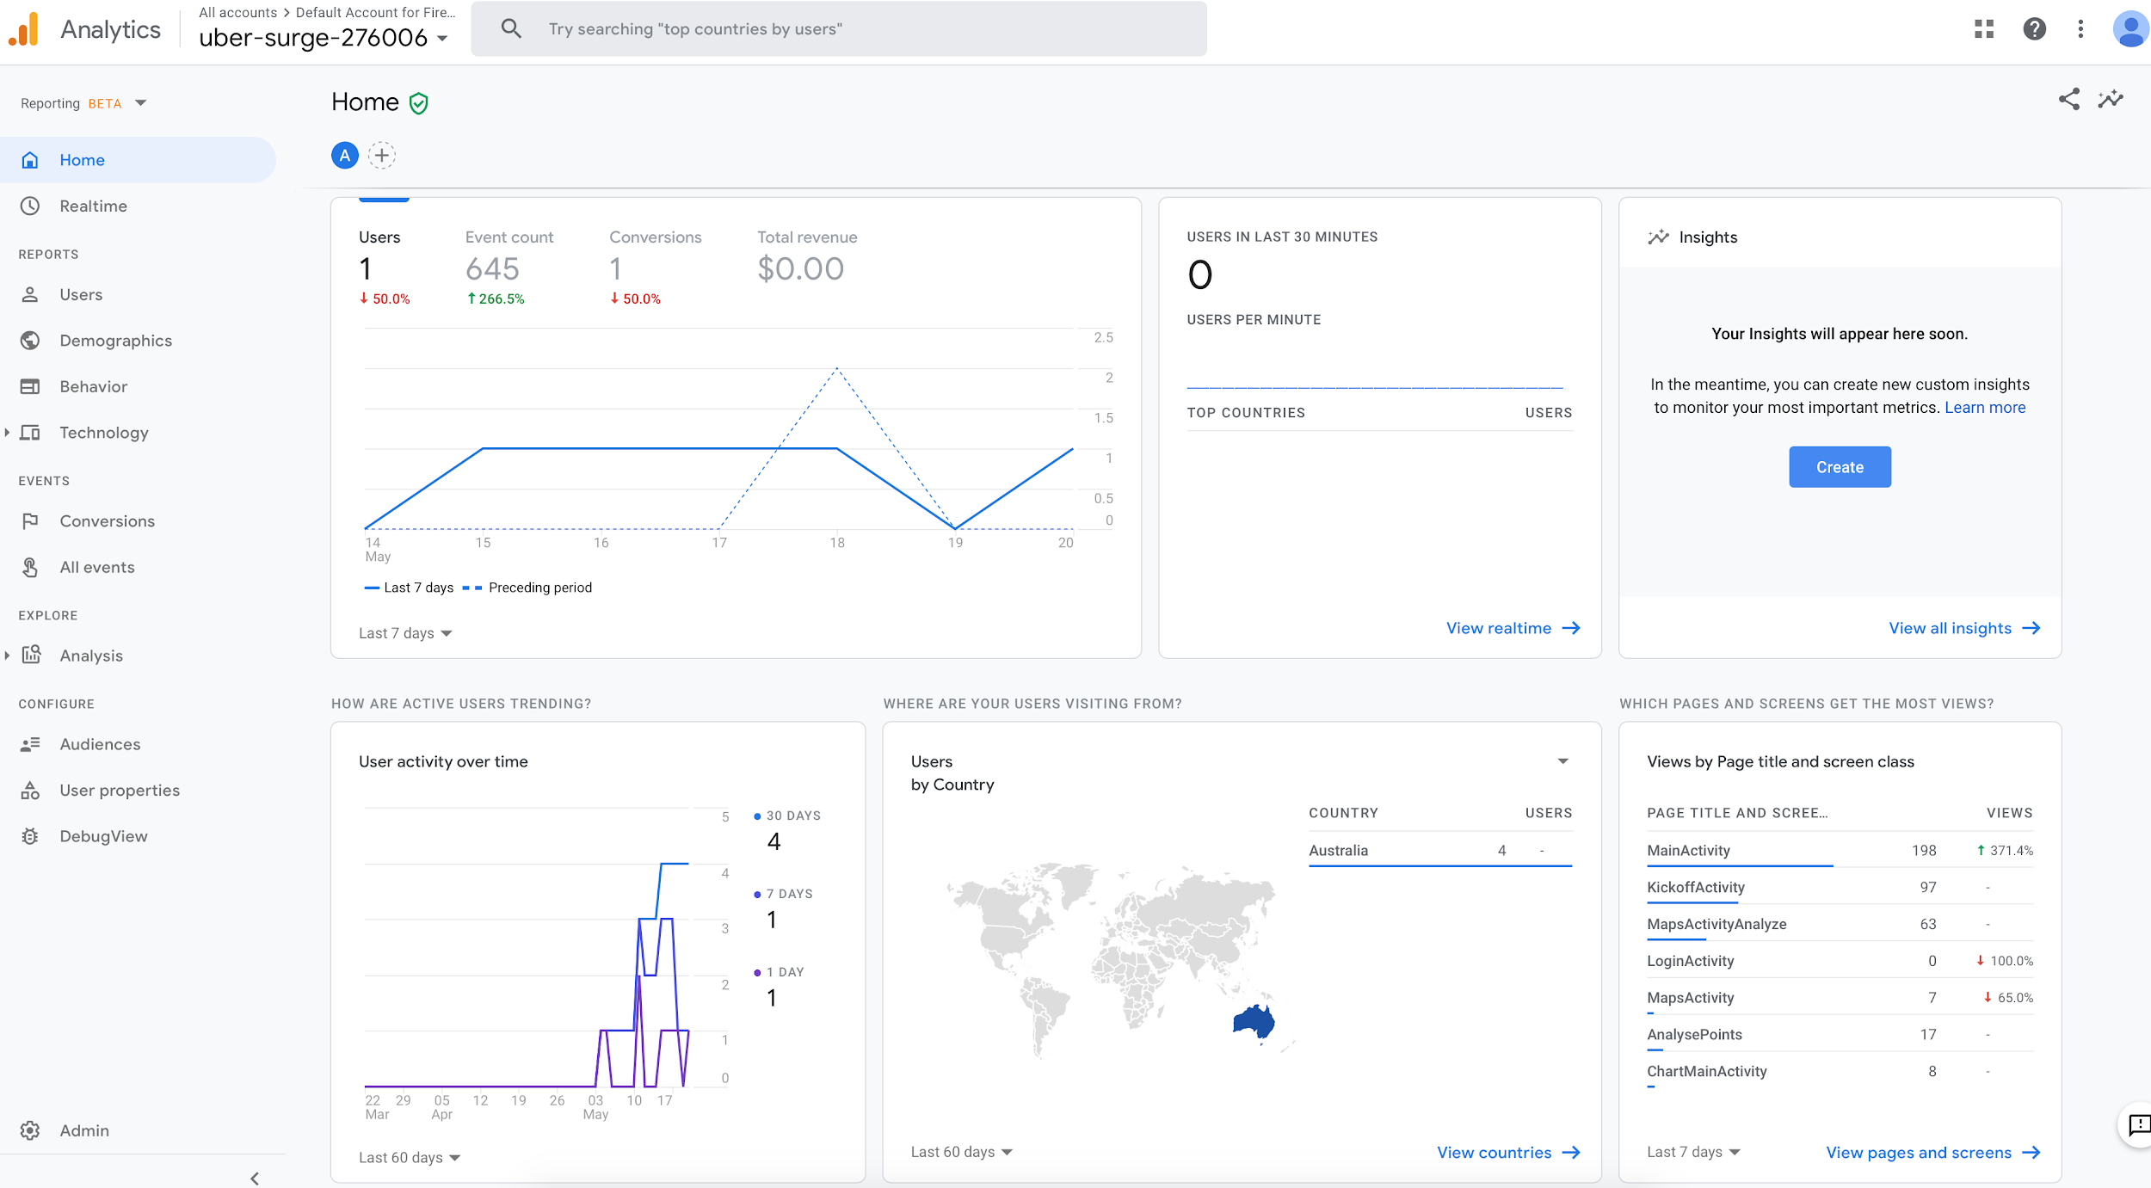

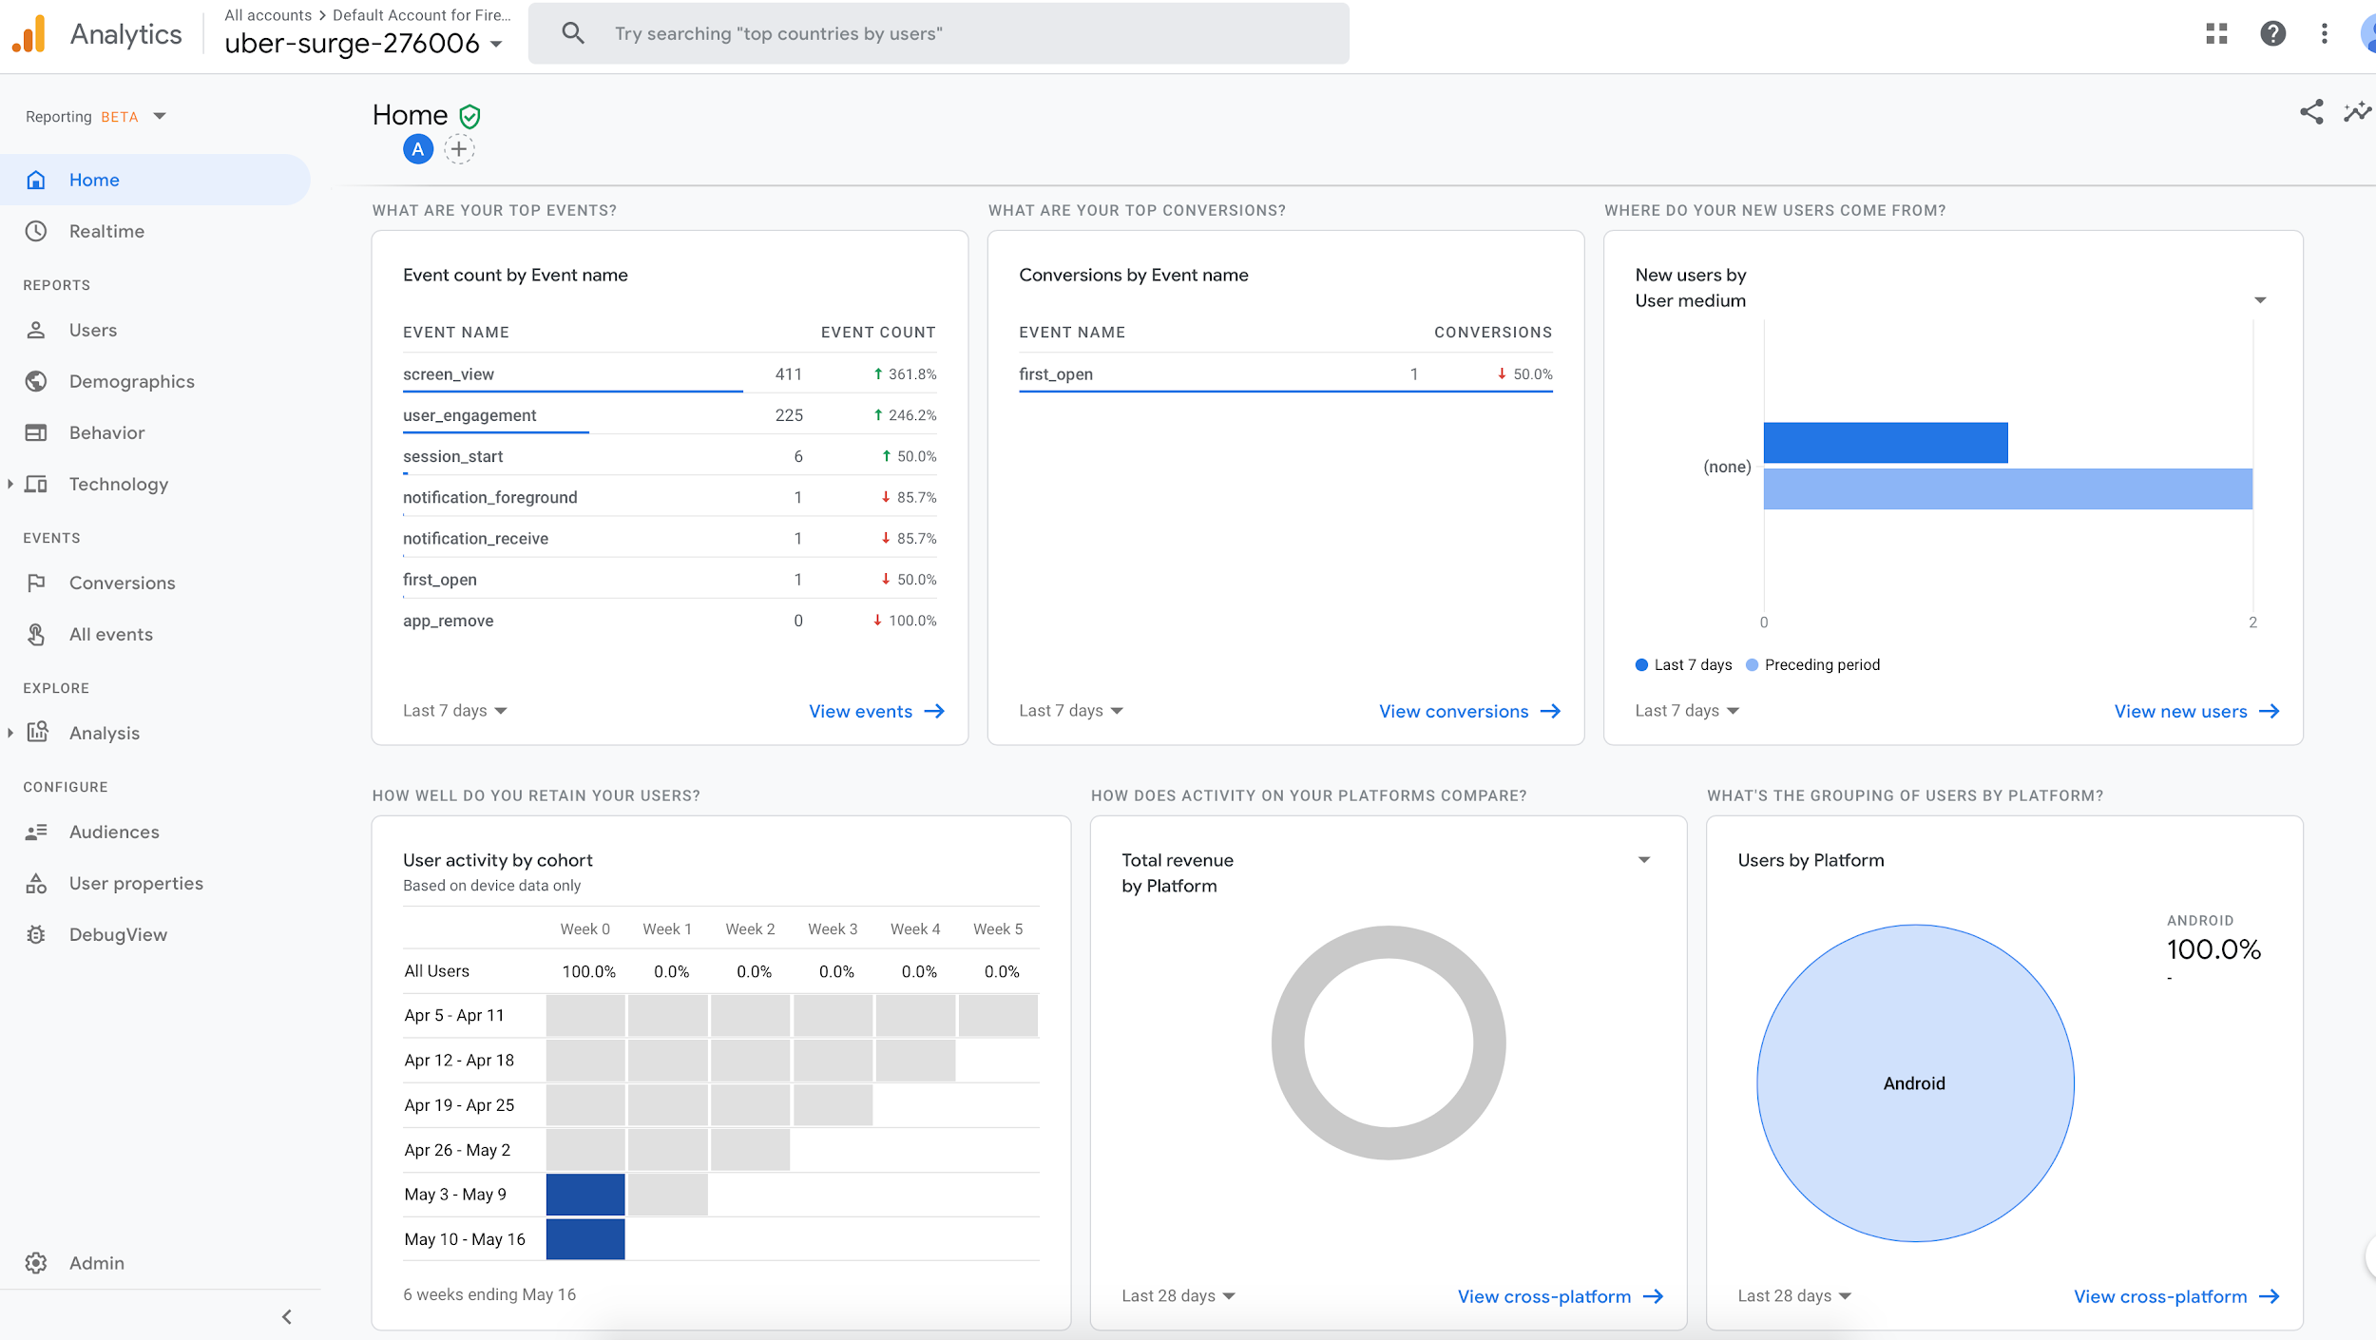

1. Running application diagram.

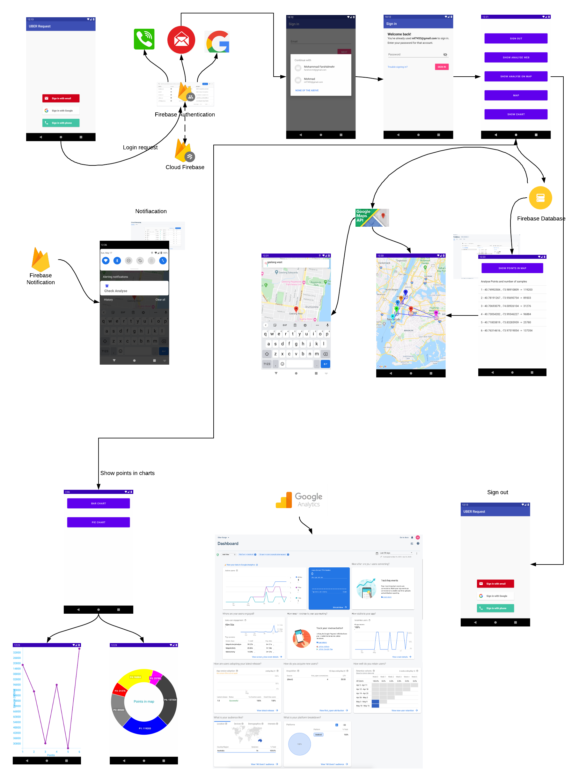

### K-Means MapReduce

We have performed MapReduce on the K-means algorithm to be able to process our large scale data in order to identify the high-demand areas. The original dataset was about 1GB which we reduced it to 22MBs and cleaned the data to be able to process it easier and visualize the results on the map more clearly. We would use 6 centroids at the beginning of the task, and by running the program, these 6 centroids will be converged to a fixed value, at the end. The Map gets a centroid and a data point, then measures the distance between them and assigns the nearest data point to each centroid and outputs a key-value pair of centroid and its associated data point. The Reducer class gets a centroid and iterable centroids as inputs, recomputes the new centroid’s position and updates the centroid. This procedure continues till all the centroids are merged and the values and clusters are fixed. Then the Job class reads a our from our s3 bucket and initiates the centroids with values, close to the real data point values which are hard coded in the program. At the end, after certain amounts of iterations, the output of all the iterations are written into a file named ”output.txt” in the output folder of our s3 bucket which results in the final clusters. Below is how our program interacts with the EMR and the s3 bucket. We upload our final .JAR file on the s3 bucket, and then create a cluster in EMR.

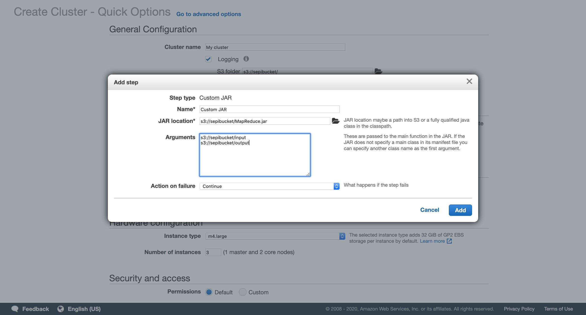

Then click on create cluster and wait for the program to be executed.

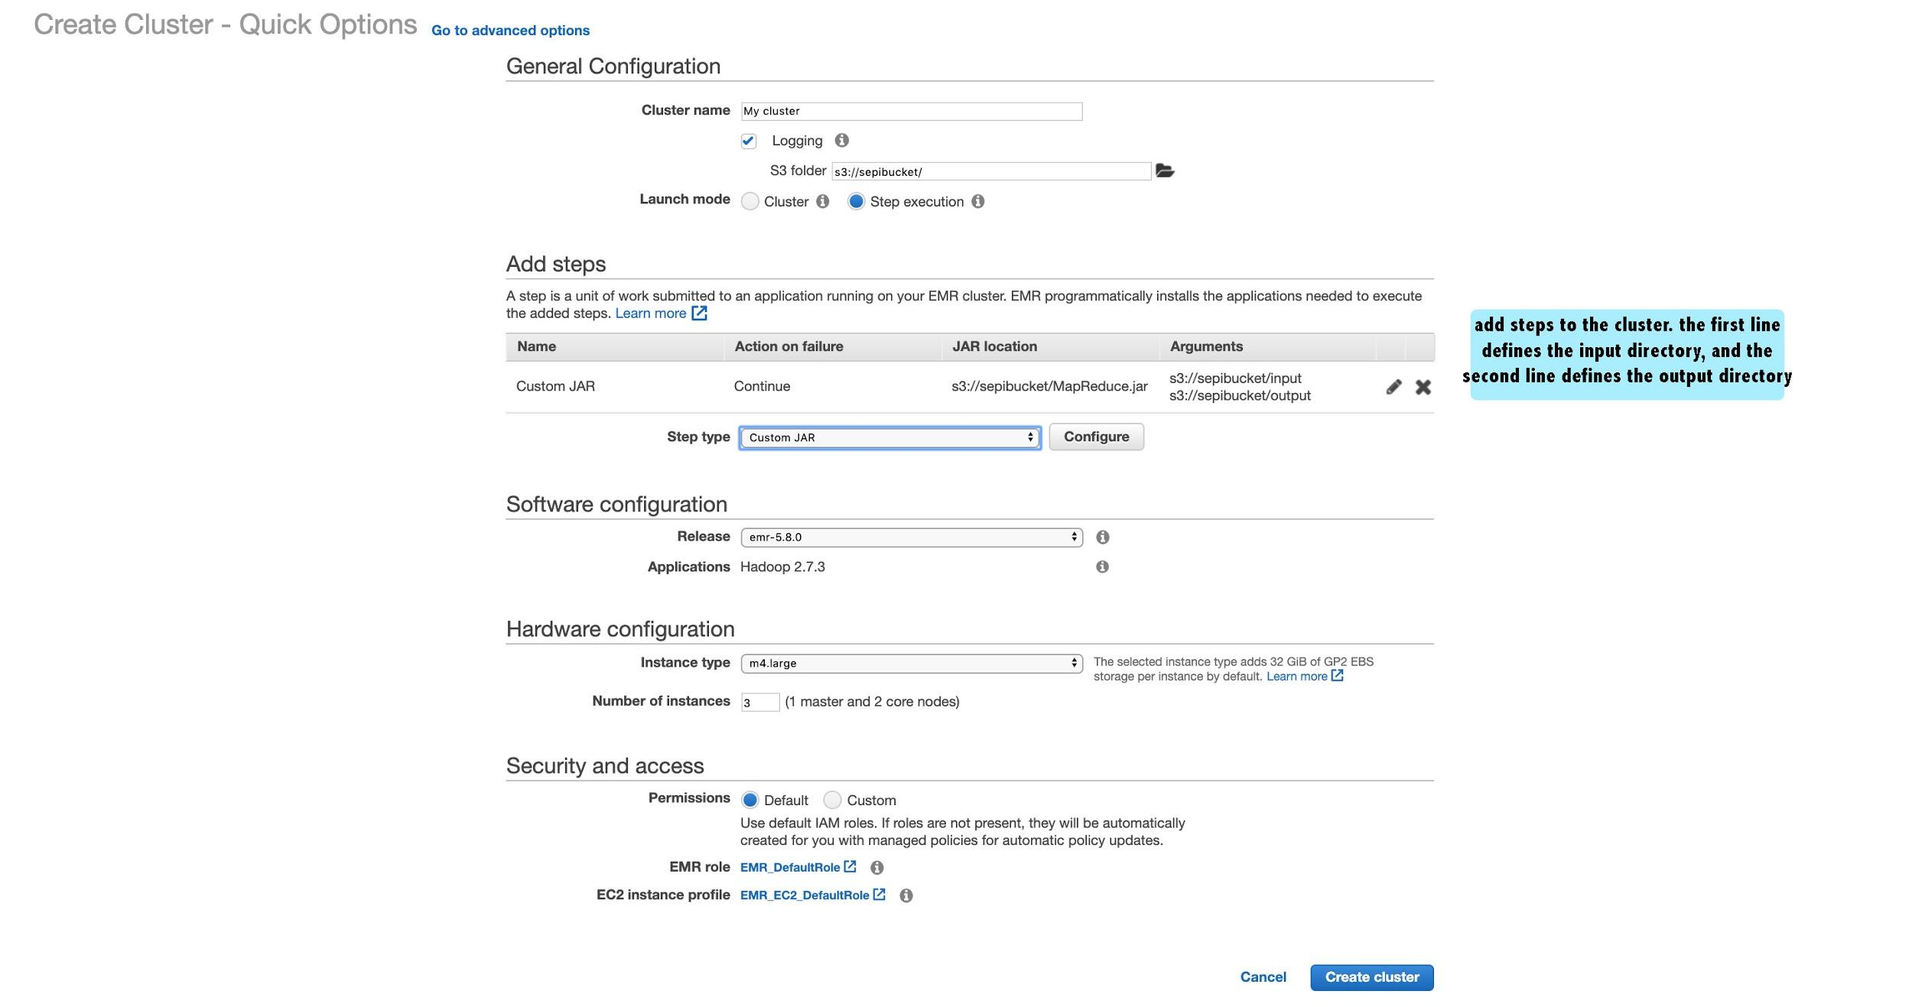

The diagram below, shows how the java program interacts with the s bucket and the emr cluster:

### 

### 

### 

### 

### 

### Data Analysis and Data Visualization

The below diagram shows the high demand centres of the clusters. We used BigQuery’s Data Studio to analyse the results from the query:

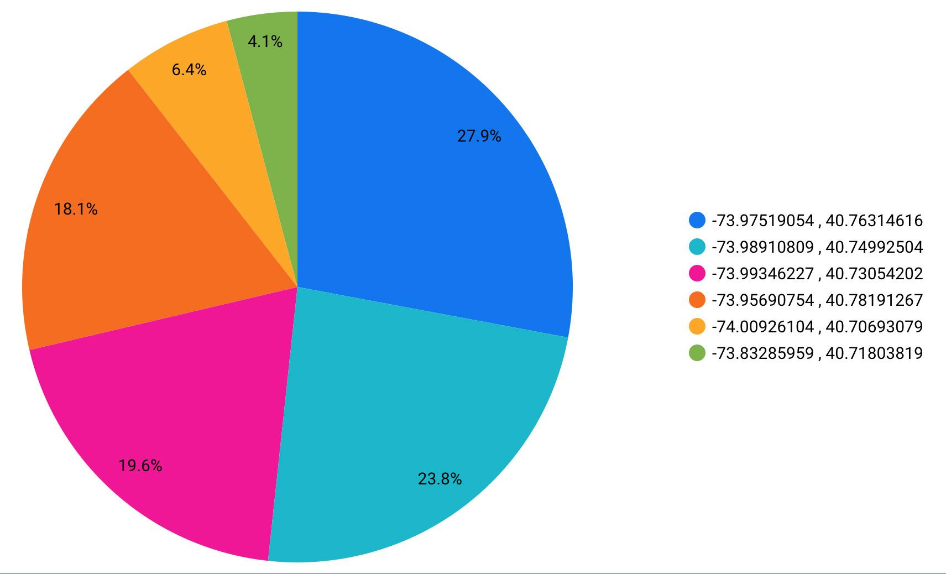

This diagram shows that there are clusters that have slightly more requests in comparison to other clusters, which means those areas are more busy areas and the density of requests in those clusters are higher.

The image below shows the 6 different cluster from our output result:

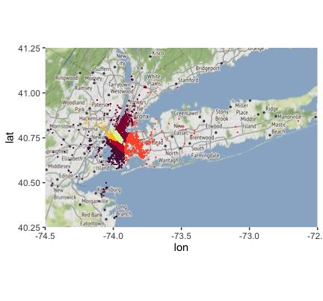

### Conclusion

# 

# 

# References

1.Traveltime.com. 2020. *3 Ways To Use Business Location Analysis*. [online] Available at: <https://traveltime.com/blog/business-location-analysis> [Accessed 17 May 2020].

i. **References**: Important references/website links that you use to develop your application.

j. **Video (optional)**: A video demonstration of your application (provide a YouTube link in the report).